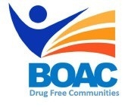

MBroeomet OipioidgAwareness Council

March 1st, 2019 | 10 a.m. - 12 p.m.

Conference Rooms B&C • Broome County Health Department

**Agenda**

**Call to Order:** Marissa Lamphere, Broome County Opioid Overdose Prevention Coordinator

**Welcome and Introductions**

1. **Approval of January Meeting Minutes**
2. **Committee Updates:**

* Broome County Prevention Coalition (Formerly Community Education)
* The Buzz Community Forums
* Media and Advocacy Committee
* Peer Response & Law Enforcement Committee
* Treatment and Prevention Committee
* Data and Statistics Committee
* Rural Committee

1. **Other Announcements/Business**

**Next Meeting:** April, 5th 2019 10am-12pm BCHD