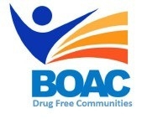

MBroeomet OipioidgAwareness Council

October 4,2019 | 10am-12pm

Conference Rooms B&C • Broome County Health Department

**Agenda**

**Call to Order:** Marissa Lamphere- Opioid Overdose Prevention Coordinator

**Welcome and Introductions**

1. **Presentation- Addiction Center of Broome County (ACBC)**
2. **Sub Committee Updates**

* Broome County Prevention Coalition (Formerly Community Education)
* Media and Advocacy Committee
* Data & Statistics Committee
* Peer Response & Law Enforcement Committee
* Treatment and Prevention Committee
* Rural Committee

1. **Other Announcements/Business**

**Next Meeting:** Friday November 1st 10am- Broome County Health Department