BROOME COUNTY
DEPARTMENT OF AUDIT AND CONTROL

ACCOUNTS PAYABLE DOCUMENTATION AUDIT

THIRD QUARTER 2015

Alex J. McLaughlin, Comptroller

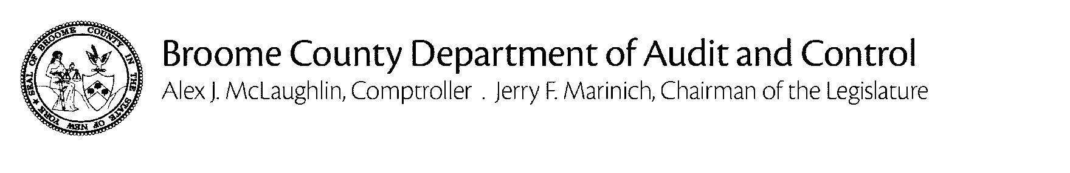
December 15, 2015

Debra A. Preston, County Executive

The Department of Audit and Control has performed an audit of Accounts Payable documentation for the third quarter of 2015. The principal objective was to verify that amounts disbursed through the accounts payable process were proper in accordance with all applicable laws, regulations and policies and that they are supported by adequate, competent documentation.

The audit was conducted in accordance with generally accepted auditing standards. Such standards require that the Department of Audit and Control plan and perform the audit to adequately assess the accuracy of the financial records and adequacy of the internal controls and that we examine, on a test basis, sufficient, competent and relevant evidence to afford a reasonable basis for our conclusions.

Based on the results of our examination, it is our opinion that, except for the instances described herein, amounts disbursed through the accounts payable process were proper in accordance with all applicable laws, regulations and policies and that they are supported by adequate, competent documentation.

Sincerely,

Alex J. McLaughlin
Comptroller

Cc: Jerry F. Marinich, Chairman of the Legislature
Members of the Legislature
Aaron M. Martin, Clerk of the Legislature
John M. Bernardo, Deputy County Executive
Department Heads
Fiscal Contacts

BACKGROUND

Weekly, Broome County processes more than 1,000 vouchers, cuts nearly 500 checks and disburses more than $7 million through its accounts payable system.

The Department of Audit and Control is responsible for auditing all of these disbursements to ensure that they are an appropriate use of County funds, that they are proper in accordance with all applicable laws, regulations and policies and that they are supported by adequate, competent documentation.

We use a two-step process to fulfill our auditing obligations with regard to accounts payable. First, we examine an electronic version of every payment request to ensure that it is appropriate, properly classified and made in accordance with applicable laws, regulations and policies. If these criteria are satisfied, the disbursement is approved. Then, we select a sample from these disbursements for detail testing. We visit each department and verify that the backup maintained to support the selected disbursements is adequate, correct and complete.

Any instances of non-compliance that we identified are included in this report.

REPORTABLE CONDITIONS

- REAL PROPERTY

County Clerk Consulting Bill Paid by Real Property.

The Real Property Department paid a $14,600.00 consulting bill on behalf of the County Clerk Department.

In accordance with Section 362, Article 7, paragraph 3 of New York State County Law: “….nor shall one fund or appropriation account be drawn upon to pay any claim chargeable to another.” The Broome County Charter and Administrative Code (Article VI) also prohibits the transfer of resources from one administrative unit to another without prior Legislative approval.

We recommend that a journal entry be prepared moving the expense from the Real Property Department to the County Clerk Department, where the charge would properly be reflected.

Response - OMB will prepare and submit through PeopleSoft workflow the necessary journal entry to move the expense from Real Property Department to the County Clerk’s Office.

- HIGHWAY DEPARTMENT

Incorrect Rates Paid to Contractor

The Highway Department overpaid a vendor by $47.50 due to incorrect rates included in the vendor’s bill.

The payment was associated with the Big Brook Stream Bank Failure project.

The Department intends to secure a credit from the vendor on a future billing.

- HIGHWAY DEPARTMENT

Retainage Not Withheld From Payments In Accordance With Terms of Contract.

The Highway Department processed payments totaling $179,057.57 without holding back retainage of 5% as required in accordance with the terms of the applicable contracts.

- WILLOW POINT NURSING HOME

County Contracts Not Utilized

During our review of Willow Point’s use of the County Purchasing Card, we found several instances of purchases made from vendors where the County has existing contracts.

County contracts are negotiated with vendors to secure more favorable terms and conditions and price discounts. When a contract exists with a vendor it should be used.

Willow Point has agreed to use existing County contracts going forward.

